Calculus 2 Lecture 10.2: Introduction to Parametric Equations

The motion of an object on a plane.

Problems with defining a plane curve like a “normal” function, 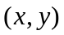
- Many times they are curves are not functions.
- Many times we cannot explicitly define “the curve” in term of a single variable and they don’t tell where an object is at a given “time”
- No direction.

Parametric Equations
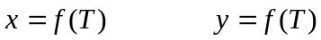
Define motion in both “x” and “y” directions as a function of some variable “T”, over a common domain calling the domain “I”

“T” is the parameter
“I” is the parameter interval

NOTE “T” is typically thought of a time. (time can be negative) (TARDIS TIME)

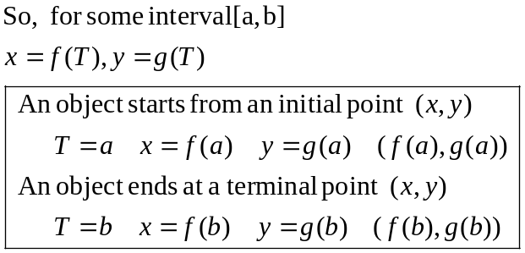

Object travels along a trajectory with a specific orientation.

Example:
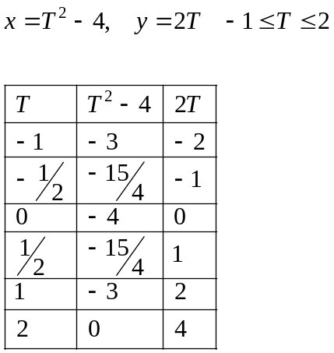

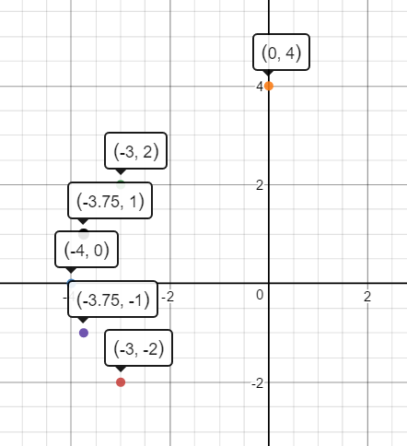
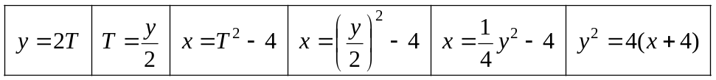

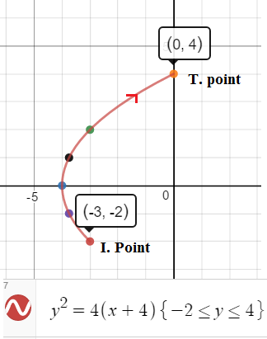
Example
NOTE: if no interval is given find natural domain of T:
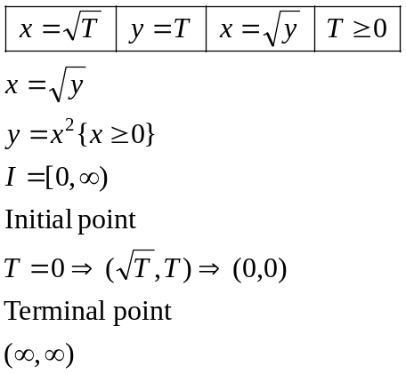

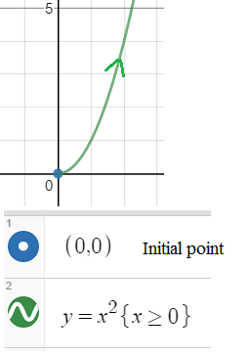

Example
NOTE: if no interval is given find natural domain of T:
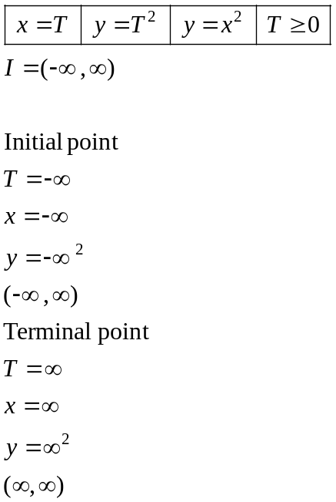

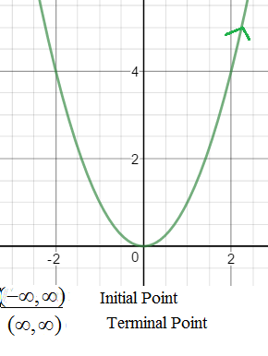
Example
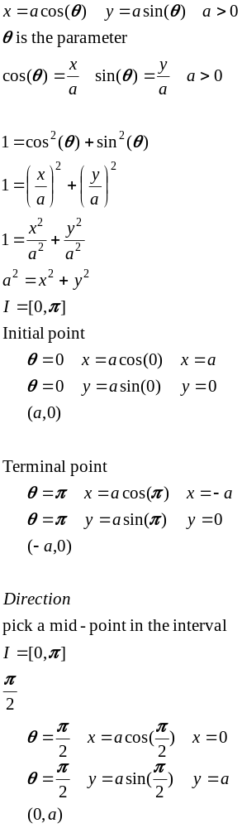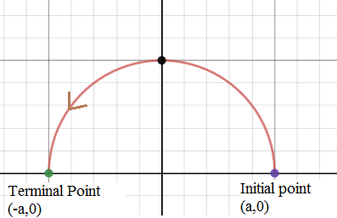

Example
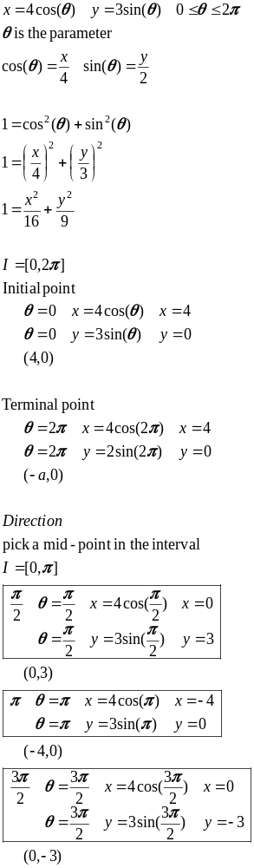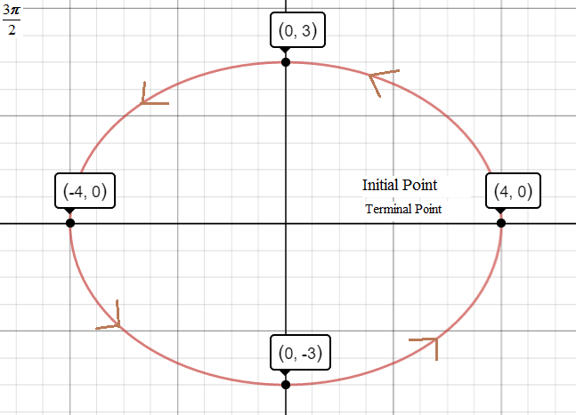
Example
